SMART PARKING MANAGEMENT SYSTEM
AI + MongoDB Powered Intelligent Parking Platform

Item | Details
Project Type | Full-Stack Web Application
Frontend | React.js
Backend | Node.js + Express.js
Database | MongoDB + Mongoose
AI | Python + YOLO/OpenCV integration
Development | Visual Studio Code

INTRODUCTION
Smart Parking Management System is a versatile and user-friendly web application designed to improve parking discovery, reservation and facility management. It combines a React.js frontend, Node.js/Express.js backend and MongoDB database with AI-assisted parking detection and prediction. The system detects or simulates free and occupied slots, predicts future availability, recommends suitable slots, supports reservations and parking sessions, manages EV charging, detects violations, provides dynamic pricing and allows administrators to create emergency corridors.
The platform is designed as a practical smart-city solution that can reduce parking search time, improve space utilization, reduce unnecessary vehicle movement and provide parking operators with real-time analytics.

SCENARIO BASED CASE STUDY
Meet Arjun, a daily commuter who regularly visits a busy commercial area. During peak hours he spends considerable time searching for parking and sometimes needs an EV charger. Arjun uses the Smart Parking Management System to register his vehicle, view live availability and request the best parking slot.
- Arjun registers and securely logs in.
- He adds his vehicle type, size and EV status.
- He opens Find Parking and views current occupancy.
- The recommendation engine evaluates distance, congestion, compatibility, EV needs, duration and price.
- The system recommends a slot and explains why it was selected.
- Arjun reserves the slot.
- At entry, the parking session begins and slot status changes.
- Dynamic pricing can adjust during high-demand periods.
- At exit, the system calculates the parking fee and stores the session.
- The administrator can see the updated occupancy, reservation and analytics.

SYSTEM REQUIREMENTS

Software Requirements
- Windows 10/11, macOS or Linux.
- Node.js v18 or above.
- npm for dependency management.
- React.js for the frontend.
- Express.js and Node.js for REST APIs and server-side logic.
- MongoDB with Mongoose for persistent data.
- Visual Studio Code for development.
- Postman for API testing.
- Python 3.10+ for the optional AI service.
- YOLO and OpenCV for optional computer-vision parking detection.
- Modern Chrome, Edge or Firefox browser.

Hardware Requirements
- Intel Core i5 / AMD Ryzen 5 or better.
- Minimum 8 GB RAM; 16 GB recommended.
- At least 2 GB free storage for dependencies and tools.
- 1366×768 minimum display; 1920×1080 recommended.
- Optional camera for future live parking detection.

PROJECT ARCHITECTURE
The system uses a modular full-stack architecture. React provides the user and admin interfaces. Express/Node provides REST APIs and business logic. MongoDB stores persistent data. Socket.IO can provide real-time slot and dashboard updates. A separate Python service can process images with YOLO/OpenCV.
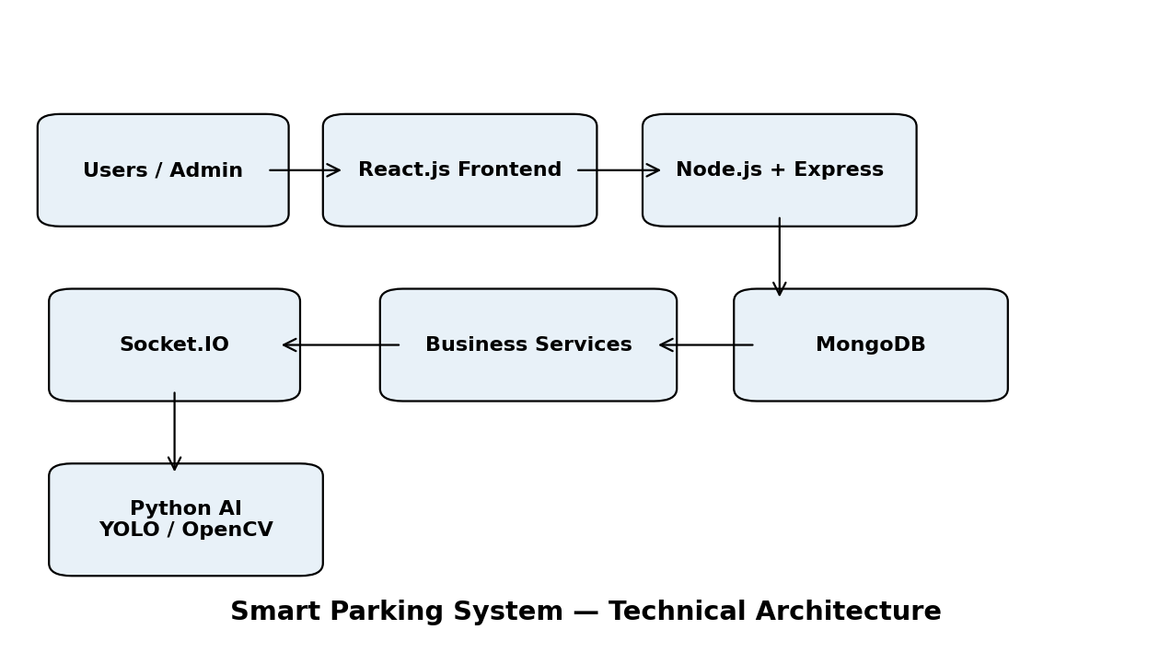

TECHNICAL ARCHITECTURE
- User or administrator interacts with the React frontend.
- Frontend sends authenticated requests to the Express.js API.
- Controllers validate requests and invoke business services.
- Services handle recommendation, reservation, pricing, prediction, EV and emergency logic.
- Mongoose models communicate with MongoDB.
- Socket.IO broadcasts live occupancy and emergency changes.
- The optional Python AI service returns parking occupancy results to the backend.
- The frontend displays processed results and updates the user interface.

ER DIAGRAM
The ER model represents the core entities of the parking platform. Users own vehicles and create reservations and sessions. Facilities contain slots. Reservations connect users, vehicles and slots. Violations are associated with users, vehicles and slots. Prediction and pricing data belong to facilities.
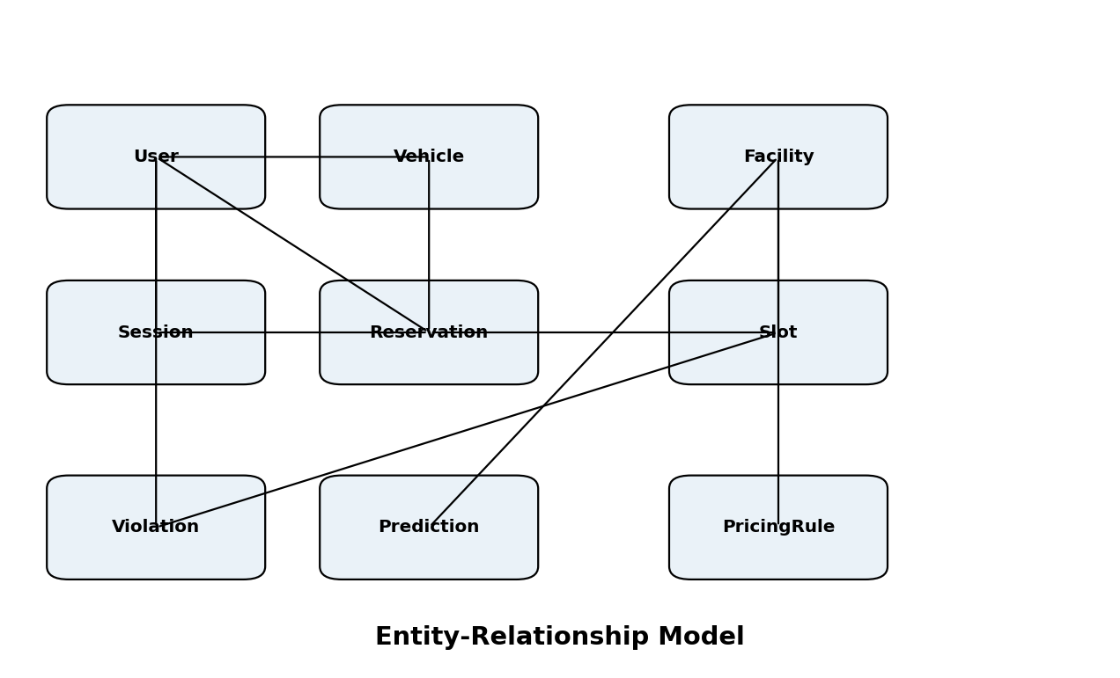

KEY ENTITIES
Entity | Purpose | Main Attributes
User | Account and role information | userId, name, email, role, phone
Vehicle | Vehicle requirements | vehicleId, userId, type, size, isEV, batteryLevel
ParkingFacility | Parking location | facilityId, name, location, totalSlots
ParkingSlot | Individual slot | slotId, facilityId, slotNumber, status, coordinates
Reservation | Planned booking | reservationId, userId, slotId, startTime, endTime, price
ParkingSession | Actual parking | sessionId, userId, slotId, entryTime, exitTime, amount
Violation | Improper parking event | violationId, userId, vehicleId, slotId, type
Prediction | Predicted occupancy | predictionId, facilityId, timestamp, predictedOccupancy
PricingRule | Dynamic price configuration | ruleId, facilityId, occupancyRange, price, active

KEY FEATURES
- User registration, authentication and profile management.
- Vehicle registration with type, size and EV information.
- Real-time or simulated parking-slot availability.
- AI-assisted slot detection using YOLO/OpenCV.
- AI slot recommendation based on distance, congestion, vehicle compatibility, EV needs, duration and price.
- Future parking-availability prediction.
- Slot reservation and cancellation.
- Parking entry, exit and fee calculation.
- Dynamic pricing based on occupancy and demand.
- Improper/overlapping parking violation management.
- EV charging-slot discovery and reservation.
- Emergency mode with priority corridor management.
- Admin dashboard with occupancy, revenue and analytics.
- Real-time notifications and Socket.IO updates.

HIGHLIGHTED HACKATHON FEATURES
Priority | Feature | Purpose
★★★★★ | Live Parking Map | Demonstrates real-time slot management.
★★★★★ | AI Recommendation | Main differentiator from basic parking systems.
★★★★★ | Reservation | Shows complete user-to-database workflow.
★★★★★ | Admin Command Center | Demonstrates management and analytics.
★★★★ | Dynamic Pricing | Demonstrates business value.
★★★★ | Availability Prediction | Demonstrates data-driven planning.
★★★★ | Emergency Mode | Demonstrates social and operational impact.
★★★ | EV Management | Supports EV charging services.
★★★ | Violation Detection | Improves parking discipline.

ROLES AND RESPONSIBILITIES

User
- Registration and Account Management: Create and manage an account securely.
- Vehicle Management: Add vehicles and maintain vehicle requirements.
- Parking Search: View facilities, availability and conditions.
- AI Recommendation: Request the most suitable parking slot.
- Reservation: Reserve, view and cancel eligible bookings.
- Parking Session: Start/end sessions and view calculated fees.
- EV Charging: Find and reserve suitable chargers.
- History: Review previous parking sessions and reservations.
- Violations: View parking violations and their status.

Admin
- System Management: Monitor overall parking operations.
- Facility and Slot Management: Create, update and monitor parking slots.
- User and Reservation Management.
- Pricing Management: Configure dynamic pricing rules.
- Analytics: Review occupancy, revenue, utilization and demand.
- Violation Monitoring.
- EV Charging Management.
- Emergency Management: Activate/deactivate priority corridors.

USER FLOW
- Registration & Login – Create an account and authenticate securely.
- Vehicle Setup – Add vehicle type, size and EV information.
- Search Parking – Select a facility and parking duration.
- AI Recommendation – Receive ranked slot recommendations.
- Reservation – Confirm the selected slot.
- Entry – Start the parking session.
- Parking – Occupancy and slot status are monitored.
- Exit – End the session and calculate the final fee.
- History – Store and display the completed session.

ADMIN FLOW
- Admin Login – Authenticate with administrator credentials.
- Command Center – View current occupancy and statistics.
- Parking Map – Monitor slot activity.
- Operations – Manage users, reservations, violations and slots.
- Pricing – Configure demand-based pricing.
- Prediction – Review future occupancy and EV demand.
- Emergency – Activate a priority corridor when required.
- Reports – Review analytics and operational performance.

MVC PATTERN
The backend follows the Model-View-Controller pattern. The separation of models, controllers and routes improves maintainability, scalability and testing.

Model Layer
Mongoose models define MongoDB schemas and data operations for users, vehicles, facilities, slots, reservations, sessions, violations, predictions, EV charging and pricing.

Controller Layer
Controllers validate incoming requests, invoke services/models and return structured responses.

View / Routing Layer
REST routes define GET, POST, PUT and DELETE endpoints used by the React application.

Advantages
- Separation of concerns.
- Easy addition of new parking modules.
- Reusable services and models.
- Independent controller/model testing.
- Better collaboration between frontend and backend developers.

PROJECT SETUP AND CONFIGURATION

Project Structure
smart-parking-system/
├── client/
├── server/
├── ai-service/
├── README.md
├── .env.example
└── .gitignore

Client Setup
npm create vite@latest client -- --template react
cd client
npm install
npm run dev

Server Setup
mkdir server
cd server
npm init -y
npm install express mongoose cors dotenv bcryptjs jsonwebtoken socket.io
npm install -D nodemon
Create folders for models, controllers, routes, middleware, services, config and utils.

Optional AI Service
cd ai-service
python -m venv venv
pip install -r requirements.txt
python app.py

BACKEND DEVELOPMENT

Backend Structure
Folder/File | Purpose
config/db.js | MongoDB connection
controllers/ | Request and business-operation controllers
middleware/authMiddleware.js | JWT authentication and role checks
models/ | Mongoose schemas
routes/ | REST API routes
services/recommendationService.js | Slot recommendation
services/pricingService.js | Dynamic pricing
services/predictionService.js | Occupancy prediction
services/emergencyService.js | Emergency corridor logic
server.js | Express and Socket.IO startup

REST API
Method | Endpoint | Purpose
POST | /api/auth/register | Register
POST | /api/auth/login | Login
GET | /api/users/profile | Profile
POST | /api/vehicles | Add vehicle
GET | /api/vehicles | List vehicles
GET | /api/parking | List facilities
GET | /api/parking/:facilityId/slots | Slot status
GET | /api/parking/:facilityId/recommend | AI recommendation
POST | /api/reservations | Create reservation
GET | /api/reservations | Get reservations
POST | /api/sessions/start | Start session
POST | /api/sessions/end | End session
GET | /api/predictions/:facilityId | Predicted occupancy
GET | /api/ev/charging-slots | EV chargers
POST | /api/ev/reserve | Reserve charger
GET | /api/violations | Violations
GET | /api/admin/dashboard | Admin statistics
GET | /api/admin/analytics | Analytics
PUT | /api/admin/pricing | Pricing rules
PUT | /api/admin/emergency-mode | Emergency mode

DATABASE DEVELOPMENT
MongoDB is the persistent data store. Mongoose provides schemas, validation and convenient access to MongoDB documents.
Collection | Stores
users | Accounts and roles
vehicles | Vehicle details and requirements
parkingfacilities | Facility information
parkingslots | Slot status and compatibility
reservations | Bookings and prices
parkingsessions | Entry, exit, duration and fee
violations | Improper parking events
predictions | Predicted occupancy
evchargingsessions | Charging reservations and sessions
pricingrules | Demand-based pricing configuration

Environment Variables
PORT=5000
MONGODB_URI=mongodb://localhost:27017/smart_parking
JWT_SECRET=your_secret_here
CLIENT_URL=http://localhost:5173
Never commit real secrets. Use .env.example for placeholders.

FRONT-END DEVELOPMENT

Frontend Pages
Area | Pages / Components
Public | Landing, Login, Register
User | Dashboard, Parking Finder, Parking Map, Reservations, Active Parking
User | Vehicles, EV Charging, Parking History, Violations, Profile
Admin | Command Center, Parking Map, Analytics, Reservations
Admin | Users, Vehicles, Violations, Pricing, EV Analytics, Predictions, Emergency Mode
Reusable | ParkingSlot, RecommendationCard, StatCard, NotificationCenter, Navbar, Modal

UI/UX REQUIREMENTS
- Use a modern smart-city visual style rather than a generic CRUD layout.
- Make the AI recommendation the primary visual element.
- Use an interactive parking map with clear slot states.
- Use green for available, red for occupied, yellow for reserved, blue/cyan for EV and strong alert styling for emergencies.
- Use dashboard cards, charts, tables, status badges and toast notifications.
- Provide loading, empty and error states.
- Keep navigation grouped so the interface stays feature-rich without becoming cluttered.
- Make the entire web application responsive on desktop, tablet and mobile.

AI AND INTELLIGENT FEATURES

Smart Slot Detection
YOLO/OpenCV can analyze a camera image or video stream and classify parking areas as occupied or available. A simulated detection mode ensures the application works without camera hardware.

AI Slot Recommendation
The recommendation service ranks available slots using distance, congestion, vehicle compatibility, EV needs, duration and price. The UI shows the recommended slot and a human-readable explanation.

Availability Prediction
Historical occupancy stored in MongoDB can be used to estimate future occupancy and expected free slots.

EV Demand Prediction
Historical charging sessions can be analyzed to estimate periods of high EV charging demand.

DYNAMIC PRICING AND EMERGENCY MANAGEMENT

Dynamic Pricing
Parking rates can change according to occupancy, demand, peak hours, duration and administrator-configured rules.
Occupancy | Level | Example Rate
0–50% | Normal | ₹40/hour
51–75% | Moderate | ₹50/hour
76–90% | High Demand | ₹65/hour
91–100% | Very High Demand | ₹80/hour
These values are example demonstration data and can be configured by the administrator.

Emergency Mode
- Admin activates Emergency Mode.
- Selected slots become restricted.
- Normal reservations for affected slots are blocked.
- An emergency corridor is highlighted on the parking map.
- System displays a prominent emergency status.
- Admin can deactivate the mode after the event.

DEMO DATA AND HACKATHON FLOW

Seed Data
- 1 administrator account.
- 5–10 demo users.
- 10–15 vehicles with varied sizes and EV statuses.
- At least 50 parking slots.
- Several EV charging slots.
- Historical occupancy records.
- Reservations and completed sessions.
- Violation records.
- Pricing rules and prediction records.

Hackathon Demo Flow
- User logs in.
- User adds/selects a vehicle.
- User opens Parking Finder.
- System shows live/simulated occupancy.
- User requests AI recommendation.
- User reserves the recommended slot.
- Admin dashboard reflects the reservation.
- Vehicle arrival changes the slot to occupied.
- Parking session starts.
- Dynamic pricing is demonstrated under high occupancy.
- Future availability prediction is shown.
- EV charger is found/reserved.
- A violation is simulated.
- Admin activates Emergency Mode.
- Emergency corridor appears on the parking map.
- Session ends and final fee is calculated.

BUSINESS AND SOCIAL IMPLICATIONS

Business Benefits
- Reduces parking management workload.
- Increases parking-space utilization.
- Creates revenue through dynamic pricing.
- Supports reservation-based revenue.
- Supports EV charging services.
- Provides analytics for better facility planning.

Social Benefits
- Reduces parking search time.
- Reduces congestion and unnecessary vehicle movement.
- Reduces parking-related stress.
- Improves accessibility through slot compatibility.
- Creates faster emergency corridors.
- Supports EV charging infrastructure.

Future Enhancements
- Live camera integration.
- License-plate recognition.
- QR/RFID parking access.
- Online payment integration.
- Navigation integration.
- IoT parking sensors.
- Advanced time-series forecasting.
- Cloud deployment and multi-facility scaling.

SECURITY, TESTING AND RUNNING

Security
- JWT authentication and protected routes.
- bcrypt password hashing.
- Backend input validation.
- Role-based authorization.
- Environment variables for secrets.
- CORS configuration.
- Backend double-booking prevention.
- No database credentials exposed to the frontend.

Testing
- Authentication and authorization.
- Vehicle CRUD operations.
- Reservation conflicts.
- Recommendation API.
- Dynamic pricing calculations.
- Parking session fee calculation.
- Emergency restrictions.
- MongoDB persistence.
- Frontend behavior during API/database failures.

Running in VS Code
# Backend
cd server
npm install
npm run dev
# Frontend
cd client
npm install
npm run dev
# Seed database
cd server
node seed.js

Typical Local Services
Service | Address
React Frontend | http://localhost:5173
Express Backend | http://localhost:5000
MongoDB | mongodb://localhost:27017

CONCLUSION
The Smart Parking Management System combines a modern React interface, Node.js/Express backend and MongoDB database with AI-assisted parking intelligence. It covers the parking lifecycle from vehicle registration and intelligent slot discovery through reservation, entry, monitoring, exit and analytics.
For administrators, the platform provides a command center for occupancy, reservations, pricing, violations, EV charging, predictions and emergency management. Its modular architecture allows future integration with cameras, IoT sensors, advanced ML models and city-scale parking networks.

Project Scope Summary
Area | Scope
Frontend | React.js responsive web application
Backend | Node.js + Express.js REST API
Database | MongoDB + Mongoose
AI | YOLO/OpenCV integration + simulation
Recommendation | Multi-factor intelligent slot ranking
Prediction | Occupancy and EV demand
Operations | Reservations, sessions, violations
Business | Dynamic pricing, reservations, EV services
Emergency | Priority corridor management
Administration | Dashboard, analytics and facility management

